Principles of Diagnostic Medicine I · Exam 1 — Study Guide
Editable Word copy of the PA_Quizzes study aid. Headings use real Word styles, so the navigation pane and the contents field below both work, and restyling one heading restyles them all.
[In Word: right-click here and choose Update Field to build the contents.]

1 · Principles of Laboratory Diagnostics
INSTRUCTIONAL OBJECTIVES
Topic Outline 1: Principles of Laboratory Diagnostics
- Define the importance and role of laboratory testing in the evaluation of a patient.
- Discuss the importance of patient counseling for diagnostic testing to reduce medical errors.
- Describe the phases of the diagnostic testing process: pretest phase, intratest phase, posttest phase.
- Explain the components of the: pretest phase, intratest phase, posttest phase.
- Identify which colored laboratory collection tubes correspond to common laboratory tests.
- Define the purpose and appropriate use of: stool studies, throat cultures, sputum cultures, blood cultures.
- Define point-of-care (POC) testing.
- Discuss common point-of-care tests performed in primary care and acute care settings.
- Compare and contrast qualitative and quantitative diagnostic tests.
- Discuss the availability, advantages, and limitations of point-of-care testing.
- Describe quality assurance measures necessary for point-of-care testing.
- Discuss accreditation and regulatory considerations related to point-of-care testing.
- Define sensitivity, specificity, positive predictive value, and negative predictive value.
- Differentiate between screening tests and diagnostic tests.
- Explain the concepts of pretest probability and posttest probability.

★ PROFESSOR EMPHASIS
★ How this course is examined
Professor Reynolds answered “what are the exams going to be like?” in the first three minutes of Lecture 1. Four things follow from it, and they shape this whole guide:
She said | What it means for you
“We always also give you the normal ranges … I’m not going to just throw a random number at you and not give you context of whether that’s high or low.” | Do not memorise reference values. If a lab value appears in a stem, its range appears with it — on this exam and, she said, in every class. Spend the effort on what the value means.
“It will be based on the instructional objectives … more related to the tests themselves rather than maybe the specific diagnosis.” | Study the test: what to order, why, its limits, how to read it. The objectives above are the blueprint.
“Although a heart rhythm can be a diagnosis, you also need to be able to interpret an EKG by naming the rhythm.” | The one stated exception. It lands on Lectures 7 and 11–16, so Exams 2 and 3.
“There could be pictures … images of x-rays or CT scans … in addition to the vignette.” | Expect image-based vignettes, not only text.

Her question style, in her own words: “which of the following laboratory tests would be best to evaluate a patient with microscopic anemia?” · “what would be the next test that you would order?”

1.1 · Objectives a & b — The role of testing, and counseling the patient
Diagnostics are tools to gain additional information, used in conjunction with a thorough history and physical examination — not in place of them. They are not necessarily therapeutic, though a blood culture that returns sensitivities certainly can be.
What testing does
Confirms a diagnosis · informs health status · evaluates disease severity · directs treatment · monitors response to therapy · guides ongoing care through regular screening

Two questions before you order anything: will it support or guide management, and is it cost effective? Appropriateness for this patient comes before availability or turnaround.
Counseling is framed as error reduction, not courtesy. Patients who are informed and understand the plan are more likely to be compliant, and compliance is what makes the result meaningful. Education covers the testing process, their questions, and the anticipated timeline for results.
Effective diagnostic testing
Communicate clearly · consider ethnicity, culture, gender and age · prepare the patient properly · follow standards · measure and evaluate outcomes · manage services with a team approach · interpret, treat, monitor and counsel on abnormal outcomes · maintain proper records

1.2 · Objectives c & d — The three phases
Each phase has its own guidelines and standards, and each has its own characteristic failures.
Phase | Also called | Span
Pretest | Preanalytical | Begins with patient preparation, extends until the test begins
Intratest | Analytical | Performing the test and everything it encompasses
Posttest | Postanalytical | Begins once the test is complete; focuses on aftercare

Most errors occur in the pretest phase. That is the single most testable fact in this section, and it is why so much of the objective is about preparation, labeling and communication rather than about the assay.
Pretest — what to consider | Pretest — how it fails
Review history and risk assessment · identify contraindications · assess coping styles, fears and phobias · observe universal precautions · document relevant data · cost and reimbursement · patient and family education · documentation · ethical and legal considerations, including consent | Communication errors · medication administration as directed · proper labeling · technical errors — inadequate blood in the vacuum tube, delay in transport, inappropriate preparation and storage · inappropriate patient preparation — fasting

Variables that can affect results: patient preparation · current drug therapy · time of specimen collection · physical activity · hydration status · age · sex · body mass index.
Intratest | Posttest
Specimen or tissue collection · monitoring the testing environment · performing or assisting the procedure · providing emotional and physical comfort · administering analgesics and sedatives · monitoring vital signs · universal precautions · proper collection · minimizing delays · monitoring for side effects or complications | Monitor for complications — bleeding, infection, respiratory difficulties, perforation, adverse effects of sedation or anesthesia · interpret results and the patient's response · identify and treat critical values · communicate results clearly and sensitively

NOTE
Integration and follow-up is the second half of the posttest phase: diagnosis, acceptance, healing and health-promoting behavior. It includes patient education, ordering appropriate follow-up labs, scheduling follow-up, making referrals, and considering emotional well-being. Behavioural responses to a significant diagnosis may last several weeks or longer. And on documentation: “if it wasn’t documented, it wasn’t done”.

1.3 · Objective e — Collection tubes and the order of draw
★ PROFESSOR EMPHASIS
★ Professor narrowed this objective
The deck carries a two-dozen-row table pairing every additive to every stopper colour. She does not want it memorised. “The thing I want you to know better, have a better handle on, is kind of the order and sort of the broad category — so light blue, think coags; lavender, we’re gonna be using this for like our CBC.” Then: “the order is important. I kind of want you to have an idea of the order.”
Her test of whether you know it: if you ordered coagulation studies and someone walks in with a lavender tube, you should immediately know that is the wrong tube.

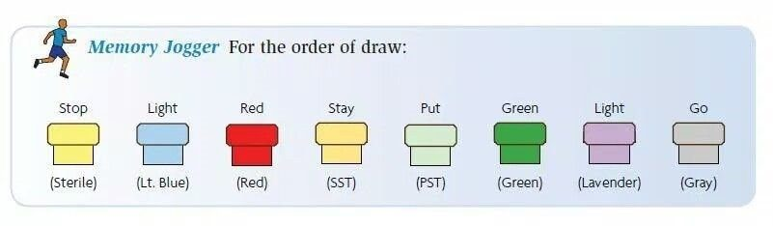
Stop · Light · Red · Stay · Put · Green · Light · Go. This is the figure to learn from this lecture. Professor Reynolds narrowed the tube objective to exactly this: “the thing I want you to know better is kind of the order and sort of the broad category.” Sterile (blood culture) first, coagulation second, non-additive next, then the additive tubes. The reason the sequence exists is to stop additive from one tube carrying into the next and corrupting the result. Source: 1. Principles of Laboratory Diagnostics sv.pptx, Slide 17.
Order | Tube | Contents | Think
1 | Yellow | Sterile media | Blood cultures
2 | Light blue | Sodium citrate | Coagulation studies
3 | Red | Non-additive serum tube | Serum chemistry
4 | Gold / tiger | Serum separator | Serum chemistry
5 | Green | Heparin | Plasma chemistry
6 | Lavender | Ethylenediaminetetraacetic acid | Complete blood count
7 | Gray | Glycolytic inhibitor | Glucose

Why the order exists: to avoid cross-contamination of additives between tubes. Carry over a little ethylenediaminetetraacetic acid into a chemistry tube and the potassium comes back wrong — the sequence is a contamination control, not a convention. The clear tube is a discard tube, used to fill the collection set's dead space before the coagulation tube when no royal blue is drawn.

1.4 · Objective f — Stool, blood, sputum and throat studies
One rule spans three of the four: get the specimen before starting antibiotics. Stated for blood, sputum and throat cultures alike.
Study | Purpose and use | The detail that gets tested
Stool studies | Non-invasive; diagnostic or screening. Indications: diarrhea, excessive flatus, abdominal discomfort, change in stool colour, recent travel, well water, prolonged antibiotics. Identifies overgrowth of normal flora, toxins, acquired bacteria, parasites | Specimen must be uncontaminated with urine or other secretions, in a dry clean container
Ova & parasites | Part of stool studies | Do NOT refrigerate — warm stool is best. Three separate random specimens, because of the parasite life cycle
Guaiac | Detects fecal occult blood; from a specimen or from the gloved finger after digital rectal examination | Heme oxidises the hydrogen peroxide in the guaiac → blue = positive. Use a small sample; a large one obscures the result
Blood cultures | Acute febrile illness with suspicion of septicemia. Both diagnostic and therapeutic — identifies the pathogen and gives sensitivities | Two separate samples from opposite arms, ideally before antibiotics. Aerobic first. Scrub and let dry; do not palpate after disinfection unless wearing sterile gloves
Sputum culture | Identifies respiratory pathogens and directs treatment | Two steps: Gram stain first (positive versus negative), then culture for identification and sensitivities. Sit upright, rinse mouth with water, three deep breaths, deep cough. Aerosols may assist. Acid-fast bacilli can be done from the same specimen
Throat culture | Isolates the pathogen, often streptococci, because of beta-hemolytic streptococcal pharyngitis. Most common ages 3–15; in adults, severe or recurrent sore throat, fever, palpable lymphadenopathy | Tongue blade improves visualization, relaxes the throat and reduces gag. Rotate the swab over the posterior throat, both tonsils, and any inflammation, exudate or ulceration. Avoid the tongue and lips. Rapid immunologic tests are highly accurate

1.5 · Objectives g, h & j — Point-of-care testing
Definition: medical testing completed outside the centralized laboratory, at or close to the site of patient care. Also called near-patient, remote, satellite laboratory testing, or rapid diagnostics. Traditional testing is multi-step and delays treatment; this brings the laboratory to the patient.
Universal features
Simple to use · reagents durable in storage and use · results align with established laboratory methods · safe during testing · performable by medical assistants, first responders, physicians, physician assistants, nurses and others — some by non-medical individuals at home

Common in primary care | Common in acute care
Blood glucose · hemoglobin A1c · urinalysis · rapid influenza · rapid strep · fecal occult blood · pregnancy testing · cholesterol · prothrombin time with international normalized ratio · drug screening  Rapidly increasing: fentanyl and human immunodeficiency virus testing | Venous blood gas · point-of-care glucose · troponin · brain natriuretic peptide · D-dimer · prothrombin time with international normalized ratio · hemoglobin and hematocrit · rapid antigen tests · urine human chorionic gonadotropin · urinalysis dipsticks  Machines: portable x-ray, electrocardiography, pulse oximetry, ultrasound

Advantages | Limitations
Convenience · rapid, less manpower · reduced visits · fingerstick rather than needle stick · better care where resources are limited — rural, disaster zone | Expensive · quality assurance difficult to control · operator and manufacturer variability · vocabulary not always standardised · results may be less precise · supply needs

The advantage and the limitation are the same coin. It is fast and close to the patient because it is not the central laboratory — which is also why it is less precise and harder to quality-control.

1.6 · Objective i — Qualitative versus quantitative
 | Qualitative | Quantitative
Answers | “Why” questions | “How many / how much” questions
Data | Observation, description | Numbers, statistical results
Approach | Observe and interpret | Measure and test
Analysis | Grouping of common data; non-statistical | Statistical analysis

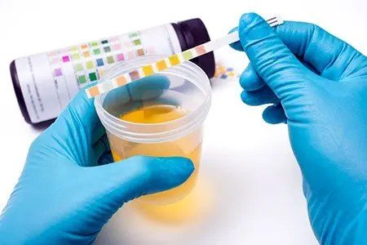
A semi-quantitative point-of-care result. The pads are matched against the chart on the bottle rather than read by a machine, which puts urinalysis between the purely qualitative tests (rapid strep, pregnancy — positive or negative) and the quantitative ones that need a reader (glucose, cardiac markers). Source: 1. Principles of Laboratory Diagnostics sv.pptx, Slide 30.
Analyser type | Examples
Qualitative or semi-quantitative cartridge | Rapid strep (qualitative), influenza (qualitative), urinalysis dipstick (semi-quantitative), pregnancy (qualitative)
Single-use quantitative cartridge or strip with a reader | Glucose — the highest-volume point-of-care test, blood chemistries, coagulation, cardiac markers, C-reactive protein, hemoglobin A1c, arterial blood gases, electrolytes
Multiple-use quantitative cartridge / benchtop | Hemoglobin species with arterial blood gas, bilirubin, electrolytes, cardiac markers, drugs

Non-instrumental point-of-care testing does not rely on instrumentation to interpret the result — urine pregnancy, coronavirus tests, fecal occult blood. Handheld equipment is easy to carry, one to two steps, few data points. Benchtop devices are stationary, multi-step, multiple data points. Both usually need reagents and consumables.

1.7 · Objectives k & l — Quality assurance and regulation
Quality measures for point-of-care testing
Supervising testing and delivery of results · operators trained and competent · collection per the device instructions · accurate patient identification throughout testing and reporting · quality control · active enrollment in an External Quality Assurance program · devices connected to electronic information systems to minimise post-testing errors · a safe, secure working environment

Clinical Laboratory Improvement Amendments (CLIA) — federal guidelines setting minimum quality standards for testing human samples at all types of sites. It began in the late 1960s after problems in the cytology laboratories reading Papanicolaou smears.
Complexity category | What it means
Waived | Little chance of a negative outcome from a false result. The Joint Commission classifies all testing outside a traditional laboratory as waived — that is, point-of-care testing
Moderately complex | The majority — roughly 75% of the 12,000 available tests. Usually automated
Highly complex | Requires operator skill and decision making; not fully automated; complex instrumentation, such as cross match testing
Provider-performed microscopy | Slide examination of a freshly collected specimen by a provider — Gram stain, manual cell count

Agency | Role
Centers for Medicare & Medicaid Services | Issues certificates · collects user fees · inspects and enforces · approves accreditation organizations · monitors proficiency testing · publishes the rules
Food and Drug Administration | Categorizes tests by complexity · reviews waiver applications · develops categorization guidance
Centers for Disease Control and Prevention | Analysis, research and technical assistance · technical standards and practice guidelines · quality improvement studies · manages the advisory committee

The direction of regulation only goes one way. Every testing site must be licensed to perform any test, the licence must match the complexity performed, and sites reapply every two years. States and cities may add requirements but may never downgrade them — so local regulation is always stricter than the federal floor, never looser.

1.8 · Objective n — Screening versus diagnostic
 | Screening | Diagnostic
Who | Asymptomatic person — looking for evidence of disease | Person with symptoms — looking for the reason
Character | Typically inexpensive, easy to perform | May be more invasive, with risk of complications
Output | Indicates whether more testing is needed; not necessarily a diagnosis | Confirmation — the “definitive” diagnosis
Sequence | Do this first, before the expensive or time-consuming test | Follows an abnormal screen, or investigates symptoms directly

The two are not fixed labels on a test — they are roles. A screening test becomes diagnostic if an abnormality is found during it: a screening colonoscopy that finds and biopsies a lesion has changed role mid-procedure.

1.9 · Objectives m & o — Sensitivity, specificity and predictive value
★ PROFESSOR EMPHASIS
★ No arithmetic on this exam
Walking the shark-bite example, she stopped before the numbers: “What do we think the percentage — we don’t, we’re not gonna do math, I’m not gonna make you do math” — and then asked only which scenario has the higher positive predictive value.
So learn the direction and the reason, not the formula. The worked figures below are here to make the reasoning concrete, not to be recomputed.

 | Sensitivity | Specificity
Measures | Test is positive when the person does have the condition | Test is negative when the person does not have the condition
Good at | Detecting disease | Excluding disease
Fewer | False negatives does not address false positives | False positives does not address false negatives
Mnemonic | SnNout — high Sensitivity + Negative rules out | SpPin — high Specificity + Positive rules in
Best for | Screening | Confirming
Example | Human immunodeficiency virus screening — very few infected individuals are missed | Human immunodeficiency virus confirmatory testing — minimises false-positive diagnoses

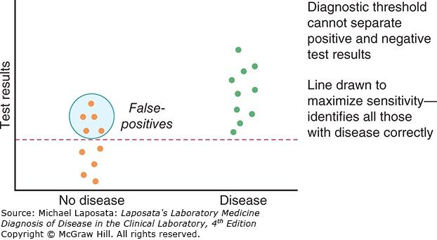
A threshold drawn to maximize sensitivity. Push the line down until every diseased patient falls above it and you catch them all — at the cost of sweeping in the healthy people circled here as false positives . This is SnNout made visual: a negative result now genuinely rules out. Source: 1. Principles of Laboratory Diagnostics sv.pptx, Slide 43.
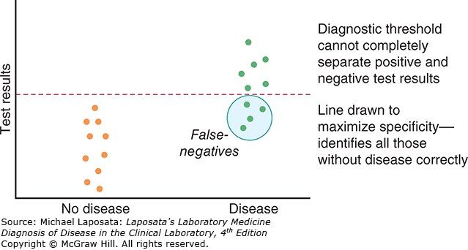
The same data, the threshold moved up. Now no healthy patient is above the line, so a positive genuinely rules in — SpPin — but the circled diseased patients below it are missed as false negatives . Read this against the figure above: it is one dataset and one dial. You cannot maximize both, which is why a sensitive test screens and a specific test confirms. Source: 1. Principles of Laboratory Diagnostics sv.pptx, Slide 43.
The two figures above are one dataset and one dial. Move the threshold down and you catch every case but collect false positives; move it up and you exclude cleanly but miss cases. That trade-off is why a sensitive test screens and a specific test confirms — and why the human immunodeficiency virus pathway runs sensitive first, specific second.
Measure | Question it answers | Belongs to
Sensitivity | If the disease is present, will the test be positive? | The test — test-centered
Specificity | If the disease is absent, will the test be negative?
Positive predictive value | My patient’s test is positive — do they actually have it? | The population — patient-centered
Negative predictive value | My patient’s test is negative — are they actually clear?

NOTE
The trap, named in the lecture. A clinician asks “my patient’s test is positive, what is the probability they have the disease?” and reaches for SnNout and SpPin — that is, for sensitivity. But it is not sensitivity, it is the positive predictive value. Sensitivity is the probability the test is positive given disease; predictive value is the probability of disease given the test. That reversal of conditioning is the foundation of Bayes’ theorem, and prevalence — the pre-test probability — is what carries you across it.

Frostbite in January, same test, 95% sensitivity and 95% specificity
Michigan — prevalence about 10%. Of 1000 tested: 95 true positives against 45 false positives → positive predictive value about 68%
Florida — prevalence about 0.1%. Of 1000 tested: about 1 true positive against 50 false positives → positive predictive value about 2%

Then she reversed it. A shark-bite detector, same 95% and 95%: in Florida a positive has a reasonable chance of being real; in Michigan, where shark bites are vanishingly rare, most positives are false. The tests are identical. The pre-test probability is what changed.
Term | Meaning
Pre-test probability | Likelihood of the condition before the result — from signs, symptoms, history, risk factors and how common it is in the population
Post-test probability | Likelihood after the result — depends on sensitivity and specificity
Prevalence | How commonly something occurs; existing cases, usually a percentage
Incidence | How often something happens — not how commonly

The one sentence to carry out of this lecture: sensitivity and specificity belong to the test; predictive value belongs to the population being tested. The test stays the same — prevalence changes the meaning of the result. Which is also why knowing the pre-test probability helps you decide whether to order the test at all.
Source: 1. Principles of Laboratory Diagnostics sv.pptx (Professor Lauren M. Reynolds, MSPA, PA-C, Course Director), Slides 1–53, and the PAJ 5600 syllabus instructional objectives. Exam-format notes are quoted from the 2026-08-18 lecture recording. Figures are reproduced from the lecture slides and each is cited to its slide. Course references: Laposata, Laboratory Medicine: Diagnosis of Disease in the Clinical Laboratory, 4th edition, chapters 1–2.

2 · Principles of Medical Imaging
INSTRUCTIONAL OBJECTIVES
Topic Outline 2: Principles of Medical Imaging
- Identify the fundamental properties of medical imaging.
- Describe the function and clinical applications of: Radiography, Ultrasonography, Computed Tomography (CT), Magnetic Resonance Imaging (MRI), Magnetic Resonance Angiography (MRA), Positron Emission Tomography (PET), Single Photon Emission Computed Tomography (SPECT), Angiographic studies.
- Discuss anatomical structures best visualized by each imaging modality.
- Compare and contrast the concepts of radiographic density and contrast.
- Discuss the importance of patient positioning in medical imaging.
- Compare and contrast the risks and benefits associated with radiation exposure.
- Compare and contrast the risks and benefits associated with contrast administration.
- Discuss contraindications and safety considerations of commonly used imaging modalities.
- Discuss the importance of communication between the physician assistant and radiology team.

NOTE
Two slides in this deck are pictures of tables, and their content appears nowhere in the text. Slide 13 carries the Hounsfield numbers and slide 21 carries the typical organ radiation doses — slide 21 in fact extracts as completely blank. Both are reproduced below. If you are studying from a text export of the deck rather than the slides themselves, those two tables are the ones you will be missing.

★ PROFESSOR EMPHASIS
★ From the lecture recording — 19 August 2026
108 minutes of audio, cross-examined against Notability’s own transcript. On the question that matters most — what is not examinable — the two transcriptions agree exactly, and there is only one such statement in the whole lecture.
She said | What it means for you
“The most important thing, and this is totally like a, like don’t stress about this. This is not gonna be on the test. This is just like a life thing… if you’re trying to trend somebody’s magnetic resonance images” [1:02:11] | The only de-emphasis in the lecture. Keeping a patient on the same scanner so serial studies stay comparable — her example was repeating scans every six months in multiple sclerosis — is practice, not exam material.
“You need to know what the view is when you’re looking at it, so that you can kind of decide, like, is this actually cardiomegaly or not?” [1:14:06] | The posterior-anterior versus anterior-posterior distinction is not trivia about beam direction. Read an anterior-posterior film as if it were posterior-anterior and you will call cardiomegaly that is not there. She adds the practical corollary: a sick inpatient who cannot stand gets an anterior-posterior film, so this comes up constantly.
“There’s your like buzzword phrase, free air under the diaphragm, perforated bowel.” [1:22:50] | She called this one a buzzword out loud, which is as close to a flag as this lecture gets. Free air under the diaphragm = perforated bowel — unless they have had recent laparoscopic surgery with insufflation and have not yet absorbed the gas. With belly pain, fever, nausea and vomiting and no recent surgery, it is perforation. The abdominal film is taken upright precisely so air floats up and fluid settles down.
“You also need to know renal function, but for kind of a different reason. Gadolinium is not necessarily nephrotoxic. It can be, but the issue is clearance of it… then it will build up in their tissues and then that is toxic. Magnetic resonance, computed tomography, kidney function, check it.” [1:40:24] | This refines the slide. The deck says gadolinium can cause kidney damage but is not as harmful as computed tomography contrast. The mechanism she wants is different: with iodinated contrast the agent is nephrotoxic; with gadolinium the kidney is the route of clearance, and impaired clearance lets it accumulate in tissue where it becomes toxic. Either way, check renal function before either.
“There should not be cross-reactivity for a shellfish allergy and iodinated radiocontrast. However, if they have an iodine allergy, absolutely you worry about allergy. But when in doubt, you’re gonna pretreat.” [1:39:11] | An important refinement on a slide that states the rule bluntly. Shellfish allergy is not iodine allergy — but a genuine iodine allergy is a concern. Her actual clinic question is: “do you have an iodine allergy, yes or no?” And when in doubt you pretreat — diphenhydramine and prednisone at intervals beforehand, plus fluids.
“Contrast media… They are also radiation. The contrast media itself can also increase cancer risk. It’s all carcinogenic.” [27:38] | She stated the deck’s carcinogenicity point flatly and then tied it straight back to the diagnostic approach: “that’s why one of the questions… is, can we do this without contrast?”
“Neoplastic agents make more blood vessels grow in that site… they become more vascularized compared to the surrounding tissues. So you inject intravenous contrast, and that tumor’s gonna light up when it’s malignant.” [1:27:54] | The mechanism the slide only implies. Contrast delineates a neoplastic from a benign mass because malignancy recruits its own vasculature. The same logic explains why an abscess enhances — inflammation, oedema and increased blood flow to the area.
“In primary care, you should never ever order that… you better have sent them to a specialist. Very dangerous.” [27:11] | On injecting contrast into a pregnant uterus. If you have reached the point of needing it, the patient has already been referred.
“You’re going to choose which side based on which direction you want to view fluid… we use decubitus positioning a lot to layer out fluid.” [1:17:47] | Decubitus is not one position but a choice of side, made according to where the fluid should run.
“Yes, you can memorize, I do a computed tomography pulmonary embolism protocol for pulmonary embolism… But if you’re like, I don’t really know for sure what this patient has, but I think something’s wrong with their bones — you’re definitely gonna pick either an x-ray or a computed tomography over an ultrasound.” [1:10:31] | Her stated method for objective c. Memorised protocols are fine, but the reliable move is to reason from the tissue: bone → x-ray or computed tomography; soft tissue → often start with ultrasound. This is also why slide 34’s structures table matters less than knowing the principle.

Quoted from the 19 August 2026 lecture recording, with timestamps. Where the recording and the slide disagree on a number, the slide wins — but where the recording explains a mechanism the slide only asserts, the recording is the better teacher.

2.1 · Objective a — Fundamental properties & the diagnostic approach
Wilhelm Röntgen discovered x-rays in Germany in 1895 and took the first Nobel Prize for Physics for it in 1901 — which is why the technique is still called roentgenography. Every modality since answers the same four questions before it is ordered:
The question | What it is really asking
Which modality is best for ruling the diagnosis in or out? | Match the study to the tissue and the question, not to habit.
Is there an alternative with less radiation? | Ultrasound and magnetic resonance use none at all.
Risk versus benefit, and patient-specific implications? | Pregnancy, age, renal function, implanted devices.
Does this need contrast, or can it be non-contrast? | Contrast adds information and adds risk.

A conventional radiograph is an image made with ionizing radiation and without added contrast such as barium or iodine. It needs a source, a way to record the image and a way to process it; radiation and light strike a photosensitive surface, producing a latent image that is processed to become visible. Radiographs are quick, inexpensive and obtainable anywhere, which is why they are the most widely obtained imaging studies — against a limited range of densities and a reliance on ionizing radiation, albeit at relatively low dose.

2.2 · Objective b — The modalities, one at a time
Modality | How the image is made | Advantages | Disadvantages
Radiography | Ionizing radiation through the body onto a detector, viewed in two dimensions | Quick, inexpensive, available anywhere, portable | Only five densities; ionizing radiation; structures overlap
Computed tomography | Powerful x-ray beams through a rotating fan beam, measuring transmission at thousands of points | Expands the grey scale beyond five densities, reduces overlap, works with implanted devices, three-dimensional reconstruction; the cornerstone of cross-sectional imaging | Not truly portable, a lot of ionizing radiation, needs space and heavy processing
Ultrasonography | High-frequency sound from a transducer, bounced off tissue and back to it | Inexpensive, portable, no radiation, real time, colour Doppler for flow direction and velocity | Cannot penetrate bone, gas disrupts the signal, deep structures are hard, operator-dependent
Magnetic resonance | A varying magnetic field aligns hydrogen; releasing it emits radio waves — essentially a hydrogen map | No radiation, superior to computed tomography for soft tissue, calcium is silent so tissue inside bone is visible, diffusion-weighted imaging for stroke | Not widely available, expensive, slow, magnetic implants and ferromagnetic projectiles
Positron emission tomography | Gamma camera reading an injected tracer, usually fluorodeoxyglucose-18; two-dimensional | Shows which tissues consume more glucose — cancer staging, brain disorders, cardiac blood flow | Among the highest-emitting devices in existence
Single photon emission tomography | Gamma cameras on a rotating gantry reading single photons; three-dimensional | Shows where blood flows — heart disease, bone scans, brain evaluation | Among the highest-emitting devices in existence
Angiographic studies | Not one test: x-ray angiogram, colour Doppler, computed tomography angiography, magnetic resonance angiography | Images vessels by whichever modality suits; magnetic resonance angiography and venography need no dye at all | Inherits the risks of whichever modality is used
Fluoroscopy | Ionizing radiation giving real-time video of the body | Evaluates motion and positioning; watches barium or iodine move through the gut, urinary tract and vessels | Needs a specially fitted unit with a tilting table; continuous radiation

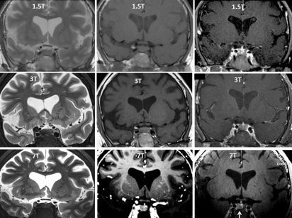
Read this grid down the columns for weighting and across the rows for field strength. The left column is T2 and the middle is T1, and the ventricles tell you which is which without reading the label: on T2 water is bright, on T1 water is dark. Fat, oedema, infection, blood and cerebrospinal fluid all follow water. Down the rows is 1.5 to 3 to 7 Tesla — same physics, more signal, finer detail. Source: 2. svPrinciples of Medical Imaging.pptx, Slide 29.
The one magnetic resonance fact that is always asked. On T2, high water content is bright; on T1, high water content is dark. Fat, oedema, infection, blood and cerebrospinal fluid all follow water. Two mnemonics, pick one: T2 = H2O is white, or just look at the ventricles in the figure above.
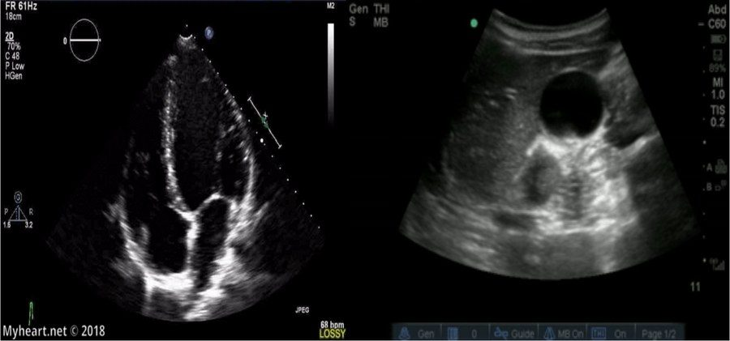
The indicator is the one thing the deck calls crucial about ultrasound. In cardiac imaging it belongs on the right of the screen; for every other ultrasound it belongs on the left . Get it wrong and the image is mirrored, which means left and right are swapped on a study you may be using to decide which side to drain. Source: 2. svPrinciples of Medical Imaging.pptx, Slide 48.

2.3 · Objective c — Which study for which structure
What you want to see | What the deck says to use
Moving structures — heart, vasculature, obstetrics | Ultrasound, which records in real time
Female pelvis, and paediatric patients | Ultrasound, often the first study of choice; also for image-guided procedures
Soft tissue — essentially anything other than bone | Magnetic resonance, with extremely high anatomical detail
Brain, and the soft tissues of orthopaedics — muscle, ligament, tendon | Magnetic resonance; it is the cornerstone of neuroimaging
Tissue surrounded by bone | Magnetic resonance — calcium emits no signal, so the bone does not obscure it
Anything cross-sectional | Computed tomography, the foundation of cross-sectional imaging
Pleural effusion | Chest radiograph in the decubitus position, so the fluid layers out
Genitourinary tract | Kidney-ureter-bladder film — supine, anterior-posterior
Gastrointestinal tract, free air, air-fluid levels | Abdominal series — standing, anterior-posterior; for obstruction, perforation, volvulus
Which organs are consuming glucose | Positron emission tomography
Where blood is flowing | Single photon emission tomography, or colour Doppler

NOTE
A note on slide 34. “Anatomical Structures Best Visualized by…” is a two-column layout that pairs seventeen modality entries against six anatomical categories, and the pairing does not survive being pulled out of the file — the columns come out as two separate lists. Every row in the table above is instead taken from a slide that states the claim in a sentence. If your own notes disagree with a row here, trust the slide in front of you: this is the one place in the lecture where the deck is genuinely hard to read mechanically.

2.4 · Objective d — Density, contrast & the Hounsfield scale
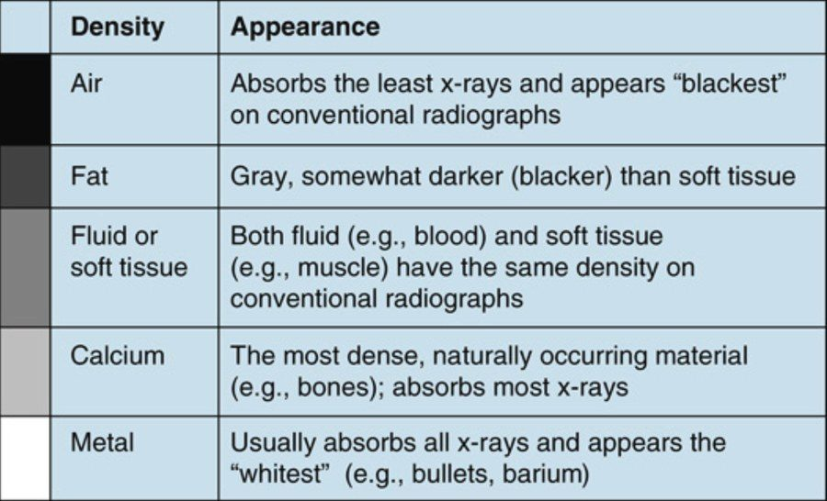
The five basic densities, and the grey-scale bar that orders them. Read the bar, not the list: air absorbs least and prints blackest, metal absorbs most and prints whitest, and everything else falls between. The row that matters for exam questions is the third — fluid and soft tissue have the same density , so a plain film cannot separate blood from muscle. Source: 2. svPrinciples of Medical Imaging.pptx, Slide 8.
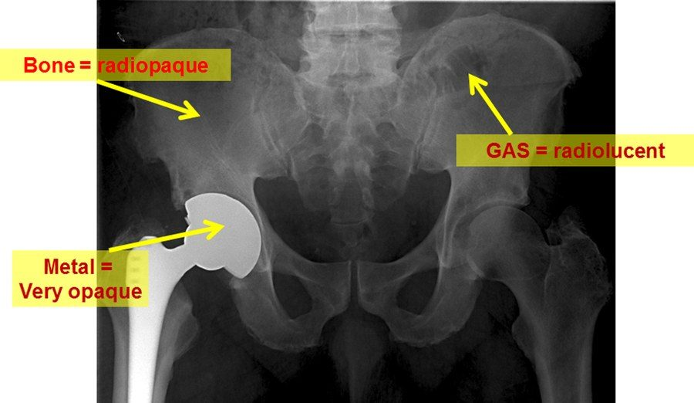
Three of the five densities in one film. The prosthesis is the brightest thing on the image because metal absorbs essentially the whole beam; bowel gas is the darkest because it absorbs almost none. Learn the vocabulary off this picture: radiopaque and hyperdense mean white because less of the beam got through, radiolucent and hypodense mean black because more did. Source: 2. svPrinciples of Medical Imaging.pptx, Slide 10.
The vocabulary. Radiolucent and hypodense both mean the image looks darker, because more x-ray photons passed through and less was absorbed. Radiopaque, hyperdense and radiodense all mean it looks whiter, because less passed through and more was absorbed. Radiation itself is measured in millisieverts and milligrays.
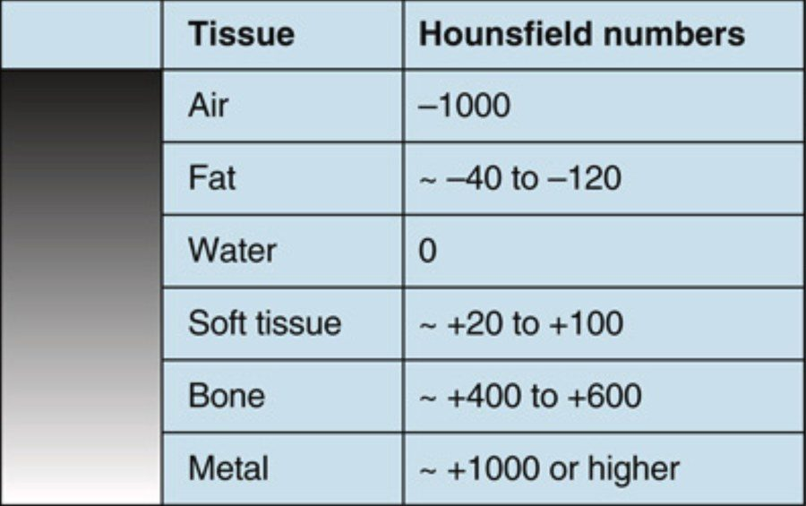
This table is only on the slide as a picture — there is no text version of it in the deck. It is the same ordering as the five densities above, given numbers. Water is zero by definition and everything is placed relative to it: negative absorbs less than water and prints darker, positive absorbs more and prints brighter. Note what computed tomography buys you over a plain film — it pulls water apart from soft tissue , which is the asterisk on this lecture's “Five*”. Source: 2. svPrinciples of Medical Imaging.pptx, Slide 13.
A computed tomography image is a matrix of thousands of tiny squares — pixels — each assigned a number from −1000 to +1000 in Hounsfield units, according to how much of the beam that point absorbed. Water is zero by convention and everything else is placed relative to it.
Term | On computed tomography | The same substance on a plain film
Increased attenuation | High Hounsfield number, appears whiter — metal, calcium | Increased density; more opaque, radiopaque
Decreased attenuation | Low Hounsfield number, appears blacker — air, fat | Decreased density; increased lucency

The window is a display choice, not an acquisition choice. A window is a pre-selected range of Hounsfield numbers — say −100 to +300 — spread across the available grey scale so the tissue of interest is separable. Because it is only a display range, the same scan can be re-windowed afterwards to bring out different pathology. That is post-processing, and its clinical value is that it demonstrates the abnormality without repeating the study and without re-exposing the patient.

2.5 · Objective e — Positioning & the imaging planes
Projections are named in the direction the beam travels, from what it strikes first to the most distal portion. So posterior-anterior means the beam enters the back and leaves the front.
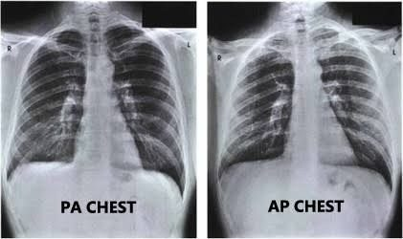
Why the projection is named in the exam question. The heart sits anteriorly, so on the posterior-anterior film it is close to the detector and its shadow is close to life size; on the anterior-posterior film it is far from the detector and is magnified . Read an anterior-posterior film as if it were posterior-anterior and you will call cardiomegaly that is not there. The other reasons posterior-anterior is preferred: less dose to radiation-sensitive organs, better lung fields and apices, and well-seen posterior ribs. Source: 2. svPrinciples of Medical Imaging.pptx, Slide 39.
Position | How | What it is for
Posterior-anterior | Standing, beam from behind; usually combined with a lateral | The standard chest film
Lateral | Side-on; the patient faces to the left on the view | Read together with the posterior-anterior film
Lateral decubitus | Lying on one side | Pleural effusion — the fluid levels out with gravity
Anterior-posterior | Beam from the front | Used when a patient cannot stand for a posterior-anterior film
Kidney-ureter-bladder | Supine, anterior-posterior | Genitourinary tract
Abdominal series | Standing, anterior-posterior | Gastrointestinal tract; air-fluid levels, free air, obstruction, perforation, volvulus

The standard chest examination is a pair. A posterior-anterior and a lateral, read together. The posterior-anterior film is viewed as if the patient were standing in front of you, their right side on your left. And comparison films are “old gold” — when you have them, the old posterior-anterior goes beside the new posterior-anterior and the old lateral beside the new lateral.
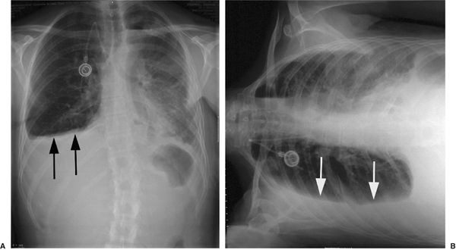
What the decubitus view is for. Lay the patient on their side and gravity moves free pleural fluid into a layer along the dependent wall, where it can be seen and measured. This is the position question with an actual answer attached: decubitus equals pleural effusion , as upright equals free air and air-fluid levels. Source: 2. svPrinciples of Medical Imaging.pptx, Slide 41.
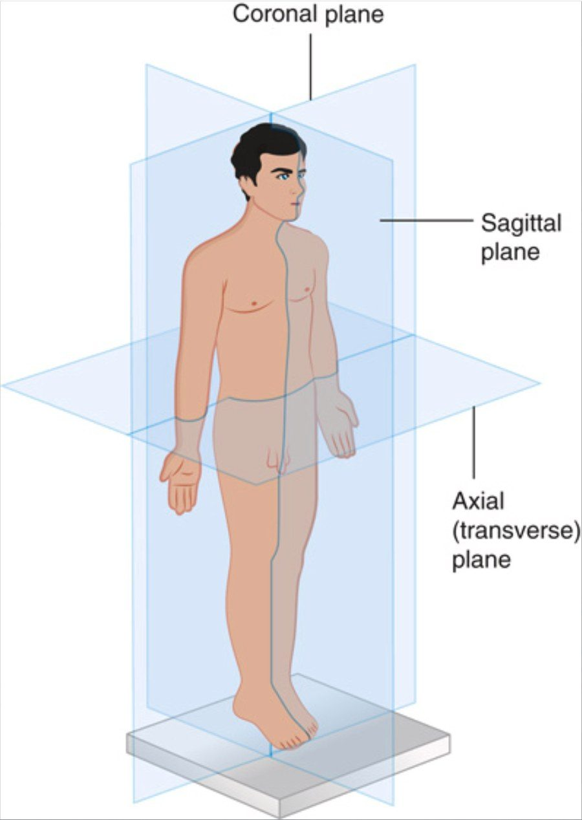
The three planes of cross-sectional imaging. Axial (transverse) divides upper from lower and is much the commonest; coronal divides anterior from posterior; sagittal divides right from left. A sagittal plane in the midline is midsagittal (median), and one off to either side is parasagittal . Pair this with the viewing convention: on a traditional axial slice you are looking at the patient's feet, so their left is on your right . Source: 2. svPrinciples of Medical Imaging.pptx, Slide 45.
For computed tomography, nuclear medicine and magnetic resonance the patient is supine, and traditional images are transverse sections viewed as if you were looking at the patient's feet — so the patient's left side is on the reader's right. Ultrasound has dozens of positions depending on the structure and the complaint, most of them some variety of supine.

2.6 · Objective f — Risks & benefits of radiation exposure
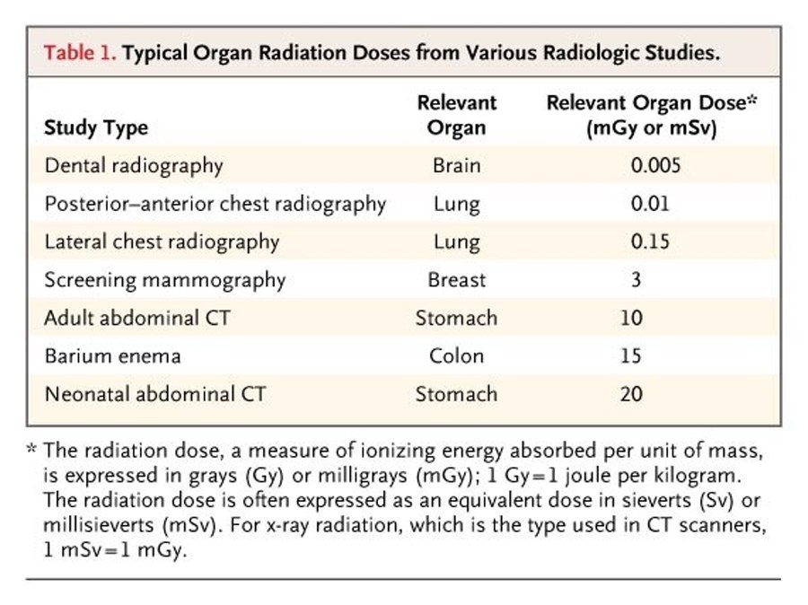
The deck's extraction reports this slide as empty. It is this entire table , and it is the only quantitative treatment of objective f in the lecture. Two things to take from it rather than memorising the column. First, the span is four orders of magnitude — a dental film and a neonatal abdominal scan are not the same conversation. Second, the neonatal scan doses twice the adult one : the smaller the patient, the larger the organ dose for the same study, which is the whole reason the diagnostic approach asks whether something with less radiation would do. Source: 2. svPrinciples of Medical Imaging.pptx, Slide 21.
Dose is ionizing energy absorbed per unit of mass, expressed in grays or milligrays — one gray is one joule per kilogram — and often as an equivalent dose in sieverts or millisieverts. For the x-ray radiation used in computed tomography scanners, one millisievert equals one milligray, which is why the table above can label a single column with either.
Computed tomography, positron emission tomography and single photon emission tomography are the highest-emitting medical imaging devices currently in existence. The deck marks this one IMPORTANT. Ultrasound and magnetic resonance emit no ionizing radiation at all; plain radiography does, but at relatively low dose.
Nuclear medicine is different in kind, not just in amount. In every other modality the machine is the source and the exposure stops when the study stops. In nuclear medicine the tracer is inside the patient, so for a while the patient is the source — they can briefly expose other people. That is the one radiation fact unique to these studies.

2.7 · Objectives g & h — Contrast media, contraindications & safety
Contrast is used most often to image arteries or veins, and to delineate and characterise masses — neoplastic against benign, infectious abscess against cyst. It also shows inflammation, increased blood flow and increased cellular or metabolic activity, and outlines luminal structures when given by mouth or as an enema. It can be injected into joints (arthrogram), into the central nervous system (intrathecal) and into the bladder (retrograde pyelogram). Because the dyes are technically radioactive, the deck names cancer as a risk factor for all contrast material.
Study | Agent | Before you give it | Watch for
Computed tomography, intravenous | Omnipaque (iohexol) — a radioactive form of iodine | Check blood urea nitrogen and creatinine; give one litre of normal saline to protect the kidneys | Nephrotoxicity. Indicated for inflammation, cancer staging, tumour delineation, vasculopathy, emboli, thrombi, stenosis, aneurysm
Angiography | Iohexol arterially, lower concentration than for intravenous computed tomography; iso-osmolal iodixanol (Visipaque) believed safer | Same renal checks | Same iodinated risks
Computed tomography, oral | Barium, or Gastrografin | Barium is contraindicated if perforation is suspected — use Gastrografin | Barium is toxic to extra-intestinal tissue and causes alkaline burns. Unpleasant taste
Fluoroscopy swallow study | Oral barium, with sequential films | Same perforation caveat | Same
Magnetic resonance | Gadolinium | Assess blood urea nitrogen and creatinine regardless — renal function matters mainly for clearance | Can damage kidneys, but not as harmful as computed tomography contrast. For central nervous system tumours, metastases, soft tissue masses, arthrograms. Magnetic resonance angiography and venography need no contrast
Positron emission tomography | Fluorodeoxyglucose-18 | Nothing specific | No contraindications, not known to be nephrotoxic; may cause hyperglycaemia; renally cleared, so the genitourinary tract is always contrast positive
Single photon emission tomography | Technetium-99 | Nothing specific | Allergic reactions rare, no organ damage documented. Bone scans, myocardial perfusion, functional brain imaging, immunoscintigraphy, sentinel node identification, white cell uptake

Shellfish allergy is not iodine allergy. The deck is explicit: there should be no cross-reactivity between shellfish and iodinated radiocontrast. What actually marks a high-risk patient is a documented anaphylactic reaction to any medication. And when contrast is genuinely necessary, pre-treatment is available. The stated takeaway: always ask about allergies and assess kidney function.

2.8 · Objective i — Working with the radiology team
- The radiologist has not seen the patient. Whatever you give them is what guides the read, so give as much relevant clinical information as you can.
- A vague report is a conversation, not a dead end. Contact the radiologist and discuss the patient.
- If you do not know which study to order, say what you are looking for. They can guide the choice; that is what the relationship is for.
- Imaging several regions may mean several orders — magnetic resonance of brain, cervical spine, thoracic spine and lumbar spine is four requests, not one.
Source: 2. svPrinciples of Medical Imaging.pptx (Professor Lauren M. Reynolds, MSPA, PA-C, Course Director), Slides 1–62, and the PAJ 5600 syllabus instructional objectives. Figures are reproduced from the lecture slides and each is cited to its slide; the Hounsfield and organ-dose tables exist in the deck only as images. The 19 August 2026 lecture recording has been folded in — see the emphasis box at the top of this section — and was cross-examined against Notability’s independent transcript.

